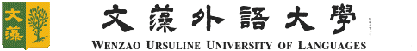
文藻外語大學 東南亞碩士學位學程
研究發現摘要
Research Findings Note

編號: RFN-__WANG__(Last Name)-_01(編碼方法請參藍字，提交時，依實際狀況繕打)___
研訪者姓名Name
學號Student No.
班級Year/Class
研訪國家Country
研訪時間Duration
研訪天數Days
累積天數 Accumulated Days
東南亞田野調查研究發現（研究問題、每日研究行程、具體研究發現並附至少三張研究照片）
Southeast Asia Field Research Findings (research question, daily research schedule, research findings and at least 3 research photos)
對日後想來該國/機構研訪的研究生建議 (如: 研訪行程安排注意事項、文化禁忌、健康注意事項等) Suggestions to other MSEAS students who plan to visit the same country or institutions (ex. tips for scheduling, cultural taboo, health recommendation, etc)

